**10 DAY TOKAT & ANATOLIAN ECOTOURISM AND SUSTAINABLE TOURISM CONFERENCE & NETWORKING EVENT (ESTC)  
  
Tour Start Date:** 27 July 2021, Tuesday **Tour Route:** Tokat – Sivas – Cappadocia Kusadasi – Ephesus and domestic flight back to Istanbul

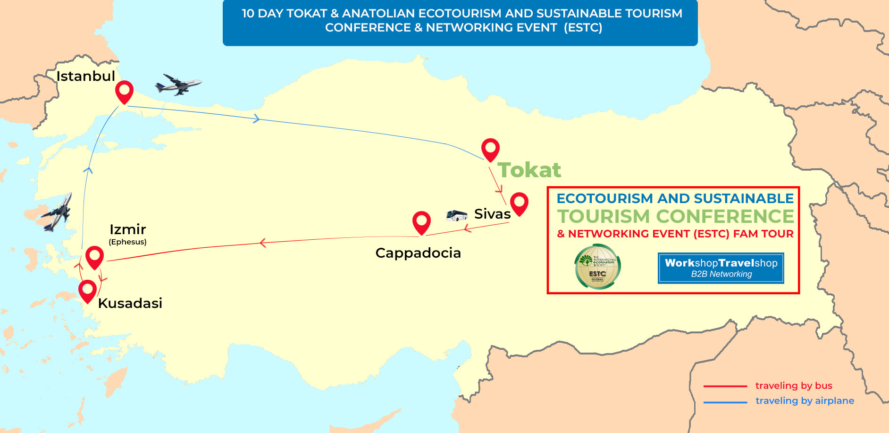

**Summary**

As The International Ecotourism Society, we organize an annual conference, the Ecotourism and Sustainable Tourism Conference (ESTC) and Business to Business Networking Event that is a widely considered the most important conference in ecotourism. The first ESTC took place in 2004 and this year, we will hold the 16th ESTC in one of the best ecological destinations of Turkey, the beautiful town of Tokat. The conference will take place by 27 July of 2021.

Attendees will be able to see, feel, touch, cook and eat while having an educational sightseeing tours in Turkey. Explore Turkey in all natural way and experience what it’s like to taste the produce, fresh off their branches, organically. Our program covers most of unique and natural destinations of beautiful Tokat, Turkey.  
While discovering all ecological aspects and discover ecotourism possibilities, you will be visiting most attractive tourist destinations of Cappadocia and Ephesus on this Fam Trip.

We will visit Sivas that has been declared as Intangible Heritage of Humanity by UNESCO in 2005. Later on, we will visit the historically unique fair chimneys and underground cities in Cappadocia.   
  
We will stay at one of the most beautiful resort cities of Aegean; Kusadasi and see the major ancient monuments of the history right before your eyes in Ephesus. With this FAM Trip, you will discover and feel a destination that you never get to experience before.

**DAY 1: Tokat Arrival Day (27 July 2021, Tuesday)***( Dinner Included )*Arrival day via Sivas or Tokat Airport for our Ecotourism and Sustainable Tourism Conference and Networking Event. Check-in to the Hotel. City sight-seeing if you would like to have it on your own, walking through the promenade leisurely prior to the main attraction. Welcome Dinner and overnight at the Hotel.   
  
**DAY 2: Tokat Downtown Tour & Ecotourism Speaker Sessions (28 July 2021, Wednesday)***( Breakfast, Lunch, Dinner Included )*Today, after an early breakfast, we will have a short City Tour visiting the famous Tokat Castle, two major and awarded Museums (historical and ethnographical) in downtown area along with Wooden Historical Residences all around us. We will witness 900 years of history in 900 steps. After the City Tour, we will have a lunch and come back to the hotel. Registrations will take place by 13:00 and until 13:30. Opening Ceremony to start by 13:30. Break-out Ecotourism sessions along with Keynote Speeches will start at 14:00 and last up until 18:00. You will have coffee breaks in between the sessions. By 19.30, we will have Gala Dinner served. Overnight at the hotel.

**DAY 3: Ecological Tour & Ecotourism and Sustainable Tourism Conference and Networking Event (29 July 2021, Thursday)***( Breakfast, Lunch, Dinner Included )*Today, after the breakfast, we will have trio sessions of B2B Meetings along with break-out sessions on certain topics by Ecotourism experts plus Keynote Authority Speaker sessions throughout the day from. Break-out Ecotourism along with Keynote Speeches to be performed between 10.00 and 18.00

B2B Networking Sessions between Buyers and Exhibitors to be performed between 13.00 and 18.00. During the During the B2B Networking sessions, all our Exhibitors to be present at their tables while Hosted Buyers to visit them in person. By 19.30, we will have dinner served. Overnight at the hotel.  
  
**DAY 4: Lake Almust, A traditional Village Visit & Peach Picking, Village Dinner and Turkish Bath (30 July 2021, Friday)**   
 *( Breakfast, Lunch, Dinner Included )*After breakfast, we will see Lake Almus, one of the largest lakes of Turkey where we will witness the variety of fish on a walking tour and after an Al Fresco lunch by the water, we will visit a village to enjoy all natural & organic food along with villagers and take a part in Folk and traditional dances, depart for peach and seasonal veggie-fruit picking at its source. Attendees will enjoy nature up close that empathize the sense of being part of the soil. Eating the peaches fresh off the branch appreciating the greatness and witness the earth. Afterwards, we will be having authentic Cuisine samples for dinner and you are cooking! Today, we will see the honored and hospitable villagers’ working conditions and cooking methods, witnessing their farm life. We will see the domestic animals all around us. An opportunity to have a perfect finish with a SPA experience at a classical Turkish Bath. Overnight at the hotel.  
  
**DAY 5: Tokat to Sivas and Sivas City Tour** **(31 July 2021, Saturday)**  
*( Breakfast, Lunch, Dinner Included )*After the breakfast in the Hotel, we will depart to Sivas. Situated at an altitude of 1275 m, Sivas is the highest city of the Central Anatolian Region and the most mountainous one with the numerous peaks. This uneven land has been the shelter of many tribes from the earliest ages to more recent periods from which remain many notable monuments. We start exploring the respectively Archaeology Museum, Sifaiye Madrasah, The Double Minaret Madrasah, Buruciye Madrasah, Castle Mosque, Gendarmerie House, Government House, Great Mosque, Broken and Curved Bridge. Later, we will give a break for local lunch. After lunch, we will go on with visiting Ottoman highlights; Meydan Mosque and Şems-i Sivasî Tomb, İhramcizade Cultural and Art House, Subaşı Karavanserai, Taşhan Karavanserai. Before dinner, we will visit Susamislar Mansion for Whirling Derwish Ceremony performance. The “Sema” ceremony is one of the most important heritage of Turkish Culture as a tradition of 800 years old. This unique traditional ritual had been proclaimed as Intangible Heritage of Humanity by UNESCO in 2005. We complete the day after dinner in Lover’ s Coffee House with drinking our classical Turkish coffee and listening local music performed by lovers who are famous with playing a stringed instrument called ‘’SAZ’’. Overnight in Sivas.

**DAY 6: Sivas - Divrigi - Kangal Tour - Cappadocia by coach (01 August 2021, Sunday)***( Breakfast, Lunch, Dinner Included )*After the breakfast in the Hotel, we will drive to Divrigi district which is about 170 km from the center. We start visiting with the Great Mosque and Hospital of Divrigi which is a remarkable building combining a monumental hypostyle mosque with a two storey hospital, including a tomb. The masterpiece Mosque has unique features of Islamic architecture. We will go on with Divrigi Castle and historical Mansions until lunch break. After lunch, we will depart for Kangal town and while our visit to Hot Spring Water Pools we will have chance to see the Kangal dogs (pronounced, khan-ghahl) is a breed of large livestock guardian dog originated in and named after this town. You will have time to spend some time in the pools for relaxing. After lunch, we depart for Cappadocia for 3-hour drive through a scenic path. Transfer and check in to your hotel in Cappadocia. Dinner and overnight in Cappadocia.

**DAY 7:** **Cappadocia Underground City & Goreme Open Air Museum** -**(02 August 2021, Monday)** *( Breakfast, Lunch, Dinner Included )*You will be picked up approximately 09.30 after your breakfast. We will drive you to Ozkonak Underground City, one of the best preserved Underground cities in Cappadocia. Then, visit to Uchisar Castle, the highest point of Cappadocia. After Uchisar, you visit Goreme Open Air Museum, the Heart of Cappadocia. Goreme Open Air Museum that is famous for frescoes dating back to 10th century describing the life of Jesus Christ and monks. Next stop is Cavusin, which is an abandoned village with old cave Greek houses. After Cavusin, you go to the restaurant in Avanos to have lunch. After lunch, you visit a pottery work shop, to see how to make potteries. Then, you go Pasabagi where you can see three - headed fairy chimneys. After Pasabagi, you visit another workshop to see Cappadocian handwoven carpets and kilims. Next stop is Devrent Valley which is also called Imagination Valley where you can see natural rock formations looking like animals. Then, you head to a wine shop in Urgup for wine tasting. Last stop is Three Beauties, three beautiful fairy chimneys with their hats, where is the symbol of Cappadocia. This tour will end approximately by 18.00 and you will be returned back to your hotel. Dinner and overnight in Cappadocia.

**DAY 8 – Cappadocia Nevsehir / Kayseri Airport to Izmir – Kusadasi - (03 August 2021, Tuesday)**  
*(Breakfast and Dinner included)*  
After breakfast, we depart for Kayseri/Nevsehir airport for our domestic flight to Izmir. Transfer from Izmir airport to your hotel. The rest of the day is yours to explore Kusadasi. Overnight in Kusadasi.  
  
**DAY 9 - Kusadasi - Ephesus Tour - Turkish Village Sirince (04 August 2021, Wednesday)**  
*(Breakfast, Lunch and Dinner included)*  
After breakfast between 08:00 and 09:30 we will pick you up from hotel for a fully guided tour of Ephesus, one of the best preserved ancient sites in the world en-route, visiting the Temple of Artemis, Curetes street, famous Roman baths, Celsus Library and Grand theater. Lunch break around 13:00. After the lunch, we will visit a place which continues to perform one of the oldest arts of Turkey; a carpet weaving center. After lunch, we will have a Turkish Village Tour. Sirince's construction style today, belongs to Anatolian Greeks. The houses on the slope are all original with their white paints. Sirince Village also has a fantastic reputation for making some of the best wines in Turkey - especially fruit wines. We will visit the vineyards and it is time to learn how to make fruit wine with Turkish wine makers. In the evening, you will be tested about your knowledge of making fruit wine. On the way, we will visit one of the famous leather production centers of the region where you will have the opportunity to get a good factory rate. On this guided tour, you will avoid the constant nagging and sometimes bullying that is well known in some markets of Turkey. Enabling you to enjoy the shopping experience whilst gaining the knowledge of the ancient craftsmen. Dinner and overnight in Kusadasi.   
  
**DAY 10 - Kusadasi, the end of Ecotourism and Sustainable Tourism Conference and Networking Event (05 August 2021, Thursday)***( Breakfast Included )*After breakfast, you will have some free time in Kusadasi. Today we depart for Izmir Airport for our domestic flight to Istanbul and then back to home. We hope you have enjoyed our Ecotourism and Sustainable Tourism Conference and Networking Event in Tokat. We hope this was a memorable event for you and looking forward to see you again on another event of ours. Thank you for joining us.

**IMPORTANT NOTICE:** If you would like to attend to the event, arriving earlier and depart later than the standard program suggests or join to an Istanbul Fam trip, please advise through[support@workshoptravelshop.com](mailto:support@workshoptravelshop.com)   
 **INCLUDES**

* Return Airport Transfer Services
* 4 nights’ hotel accommodation in Tokat
* 1-night hotel accommodation in Sivas
* 2 nights’ hotel accommodation in Cappadocia
* 2 nights’ hotel accommodation in Kusadası
* 9 Open Buffet Breakfasts
* 7 Lunches
* 9 Dinners
* Guided Tour of Ballica Cave and Zile Castle Tour
* Guided Cappadocia Tour
* Guided Ephesus Tour - Turkish Village Sirince Tour
* Guided Sivas Tour
* Guided Almus Lake Visit
* Guided Village & Farm Visits
* B2B Networking Event Participation
* Ecotourism Speaker Sessions
* English Speaking tour guides
* Professional English speaking tour guides

**EXCLUDES**

* International flights (It is only included for Fully Hosted Buyer category)
* Insurance: All types
* Country entry visa
* Items of a personal nature such as alcoholic beverages, cold drinks, laundry etc.
* Any others expenses that are not mentioned in the included section

IMPORTANT NOTICE:

“ESTC will conform to the highest safety standards and procedures as defined by ICCA, and will hold *all attendees and exhibitors to the strictest standards. “*

TERMS AND CONDITIONS

* Abide by the event calendar.
* Act in line with departure times.
* Hosted Buyers not to promote their own “incoming” services to the participants and if detected, would be disqualified and charged for the full fee.
* Minimum 30 pre-appointments taken per Hosted Buyers that to be signed by the appointee.
* Accommodations assigned should be taken into consideration and may not be altered during the trip in Turkey.
* Flight details to be registered on the system and we are not responsible of transfer services for the ones that are not registered.
* Please check your appointments and business cards.
* Only registered parties can enroll in Hosted Buyer Program. No one else can be invited without prior permission. Only the officially invited ones may stay through the event.
* We are expecting all Hosted Buyers to pay necessary attention and care for this event.
* You can ask for help of our team to be located in Hosted Buyer area throughout the event.
* Accepted invitations to Hosted Buyers are non-transferable. In case, where the Hosted Buyer is no longer able to attend, another attendee from their organization may replace with a renewed application, placed 45 days prior.
* Hosted Buyers who do not inform the Organizer of their cancellation and do not participate in the program, will be deemed a No-Show at 100%.
* All cancellations are subject to a written request and to be confirmed in return.
* Land tours “only” cancellation policy: Fully refundable in any cases and credit towards to the next event under Force Majeure conditions till 3 weeks’ event start date. 3 Weeks before 100% credit, 2 Weeks before Non-refundable.

**P.S** Whether you have altered the dates and/or any Event and Fam Trip purchases made by you from our product selection, you may use the credit by the rates as indicated above towards your purchases for the duration of 1 years on Workshop TravelShop events.